BRIGHTON FENCING CLUB
Fencing Classes – Wednesday After School Club
for 7+ year olds
Seen Zorro or Pirates of the Caribbean? Want to learn the art of sword fighting just like the heroes of these movies, or the real life Olympians?
With the Olympics still in the memory, here is your opportunity to try the sport of Fencing, with sessions run by Australian Fencer and Victorian Coach Chris Jones and Former GB Team member and Australian National Champion Steve Glaister.
We teach practical skills in an easy to understand, hands on environment. Let the kids and adults alike enjoy a fun and healthy activity, learning the art of fencing, starting with plastic foils and masks, and see how their tactical planning and imaginations can grow!
WHEN WHERE
1 hour classes on Wednesdays starting 7th August 2013 Brighton Grammar School (likely)
Brighton Gymnasium

MORE INFORMATION See www.swordfightersaustralia.com or call Chris Jones on 0409 013 171. Email: chris@swordfightersaustralia.com
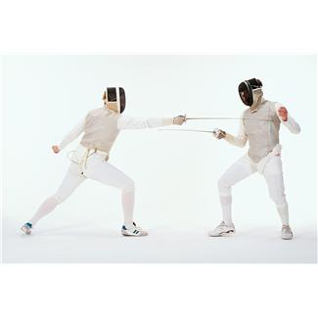
Classes
Class 1: 5:30-6:30pm 7-12/13yrs Kids Beginners
Class 2: 6:30-7:30pm 13+ Older Beginners
Session 3: 7:30-8:30pm+ Experienced Training/Squad
Lessons and private sessions, footwork and electric’s.
enjoy

